System and Software Architecture Description (SSAD)

ISTARTONMONDAY

TEAM # 03

Team members | Role
Kandarp Nyati | Project Manager
Fei Li | Operational Concept Engineer
Tanya Gautam | Requirement Engineer
Bharat Shugani | Software Architect
Thammanoon Kawinfruangfukul | Life Cycle Planner
Mark Villanueva | IIV&V

12/12/2011

Version History
Date | Author | Version | Changes made | Rationale
10/09/2011 | B.S. | 1.1 | - Section 1,2 | - Initial draft for use with Instructional ICM-Sw v1.0
10/14/2011 | B.S. | 1.2 | - Section 1,2 | - Remove Bugzilla Error  - Diagrams and Tables updates as per the graded document
10/16/2011 | B.S | 1.3 | - Section 1,2 | - Diagrams Updated, Use Case descriptions updated
10/18/2011 | B.S. | 1.4 | - Sections 1,2 | - Table 1 and 2 Updated, Use case Diagram Updates, Bugs resolved as per notified via bugzilla
10/24/2011 | B.S. | 2.0 | - Section 2 updates  - Section 3 added | - As per comments from ARB  - Requirement of DC package
10/28/2011 | M.V. | 2.1 | - Section 2.1.3.x -- Updated tables 3, 9,13, 15, 27,32,37,46  - Section 1.2 | - Win Condition text was missing and some WCs were not applicable  - Updated phase and version info
11/07/2011 | B.S. | 2.2 | - Section 1,2 | - Status and Tables updated as per the bugs
11/21/2011 | B.S. | 2.3 | - Section 1,2 | - Index updated and document changed as per the remarks in graded docment
11/23/2011 | B.S. | 3.0 | - Section1, 2 | Version and naming changes
11/27/2011 | B.S. | 3.1 | - Section 2 | Missing diagram in place
11/29/2011 | B.S. | 3.2 | - Section 2 | Artifact diagram and use case tables updated
12/05/2011 | B.S. | 3.3 | - Section 1,2 | Updated as per the comments from the ARB, process diagram updated

Table of Contents
System and Software Architecture Description (SSAD) i
Version History ii
Table of Contents iii
Table of Tables iv
Table of Figures vi
1. Introduction 1
1.1 Purpose of the SSAD 1
1.2 Status of the SSAD 1
2. System Analysis 2
2.1 System Analysis Overview 2
3. NDI/NCS Interoperability Analysis 17
3.1 Introduction 17
3.2 System Structure 18
3.3 Evaluation Summary 18

Table of Tables
Table 1: Actors Summary 3
Table 2: Artifacts and Information Summary 4
Table 3: Process Description – Browse Jobs 5
Table 4: Typical Course of Action – Browse Jobs 5
Table 5: Alternate Course Of Action – Browse Jobs 6
Table 6: Process Description – Search Jobs 6
Table 7: Typical Course of Action – Search Jobs 6
Table 8: Exceptional Course of Action – Search Jobs 6
Table 9: Process Description - Register 7
Table 10:Typical Course of Action - Register 7
Table 11: Alternate Course of Action - Register 7
Table 12: Exceptional Course of Action - Register 7
Table 13: Process Description – Manage Subscription 8
Table 14: Typical Course of Action – Manage Subscription 8
Table 15: Process Description - Login 8
Table 16: Typical Course of Action - Login 9
Table 17: Alternate Course of Action - Login 9
Table 18: Exceptional Course of Action - Login 9
Table 19: Process Description - Logout 10
Table 20: Typical Course of Action - Logout 10
Table 21: Process Description – Manage Job Seeker Profile 10
Table 22: Typical Course of Action – Manage Job Seeker Profile 10
Table 23: Exceptional Course of Action – Manage Job Seeker Profile 11
Table 24: Process Description – Testimonials 11
Table 25: Typical Course of Action – Testimonials 11
Table 26: Exceptional Course of Action – Testimonials 11
Table 27: Process Description – Post a job 12
Table 28: Typical Course of Action – Post a Job 12
Table 29: Alternate Course of Action – Post a Job 12
Table 30: Process Description – Search Candidates 13
Table 31: Typical Course of Action – Search Candidates 13
Table 32: Process Description – Manage Employer Profile 13
Table 33:Typical Course of Action – Manage Employer Profile 14
Table 34: Exceptional Course of Action – Manage Employer Profile 14
Table 35: Process Description – Manage Advertisement 14
Table 36: Typical Course of Action – Manage Advertisements 14
Table 37: Process Description – Manage Sponsor 15
Table 38: Typical Course of Action – Manage Sponsor 15
Table 39: Process Description – Send Email notification 15
Table 40: Typical Course of Action – Send Email Notification 15
Table 41: Alternate Course of Action – Send Email notification 16
Table 42: NDI Products Listing 17
Table 43: NDI Evaluation 18

Table of Figures
Figure 1: System Context Diagram 2
Figure 2: Artifacts and Information Diagram 4
Figure 3: Process Diagram 5
Figure 4: System Structure 18

Introduction

Purpose of the SSAD

The purpose of the SSAD is to document the results of the analysis and design of the project ISTARTONMONDAY. This document will serve to be the base structure for the developers of the system and act as a reference to keep a check on the operational and logical flow of the system. This document will also serve as an artifact to understand the underlying mechanism of the projects functionality for the maintainers and business experts and also as a starting point if the system is planned to be evolved.

Status of the SSAD

The current version of the SSAD is 3.3 and is part of the Transition Readiness Review Package. The document provides an overview of the system, describes the system context, describes artifacts and information created by the system, and describes the behavior of the system.

System Analysis

System Analysis Overview
The main goal of the project ISTARTONMONDAY is to make the already running project more usable and bridge the gap between the Employers and job-seekers. The project is mainly targeted to job-seekers having low-level skills. The evolved system will provide the administrator of the website with a better interface. It will create a profile management system for both employers and job seekers. Both ends will be provided with search and filtering options to view opportunities and be fit for each other in a better way. The system is also going to contain automatic and bulk notification system so that the users don’t have to come to the website over and again for small updates. This will create more opportunities for job seekers and less effort on the side of employer for finding a candidate and hence satisfy the aim of this non-profit organization.

System Context
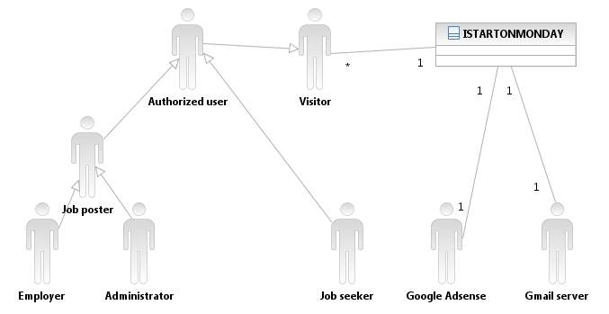
Figure 1: System Context Diagram

Table 1: Actors Summary
Actor | Description | Responsibilities
Visitor | Any general internet user who comes on the website | - Browse the website  - Search job opportunities  - Subscribe to email notification  - Register on the website with a specific role
Authorized User | A user who is registered with the website and hold a username and password | - Browse Website  - Search Jobs  - Login  - Logout
Job Seeker | A website user who has a profile of a job seeker | - Authorized User functionalities  - Manage Subscriptions  - Manage Job-Seeker Profile
Job Poster | A website user who can post jobs on the website | - Authorized User Functionalities  - Post a job
Employer | A job poster who is registered as an employer to the website | - Job Poster Functionalities  - Manage employer profile  - Search candidates for a job requirement
Administrator | A job poster with administrator privileges | - Job Poster Functionalities  - Manage Advertisement  - Manage sponsors  - Send email notification  - Manage Website Content
Gmail | Email service by Google | - Manage an email account for all notification sent via email
Google Adsense | Advertisement service by Google | - Provide publish ready advertisements

Artifacts & Information
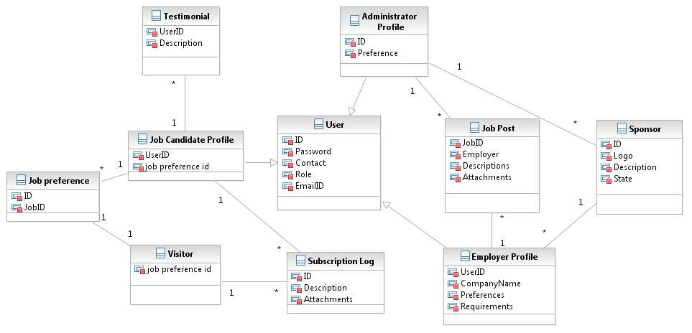
Figure 2: Artifacts and Information Diagram
Table 2: Artifacts and Information Summary
Artifact | Purpose
User | A user of the website
Job Candidate Profile | Profile of the job seeker containing the preferences and personal information
Subscription Log | Records subscriptions of job seekers and visitors of the website
Testimonial | Feedback from the job seekers
Employer Profile | Profile of the employer posting the job containing all the details regarding the employer
Job Post | A post on the website containing the description of the job opportunity and requirements and the procedure to apply for it
Administrator Profile | The person who controls and moderates the website and its activities
Sponsor | All the companies sponsoring the cause of the website or acting as major employers in the website

Behavior
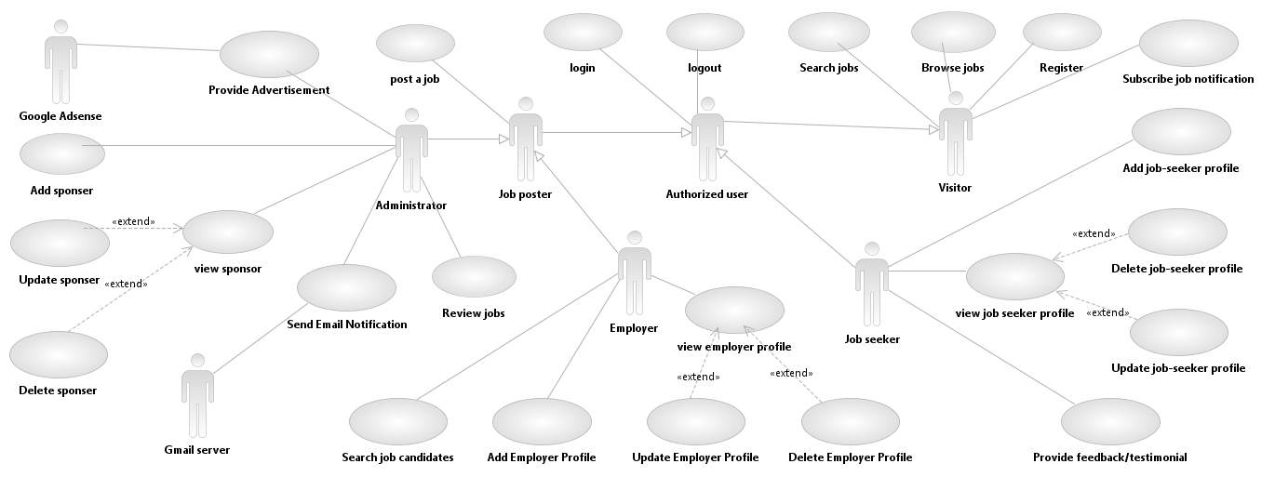

Figure 3: Process Diagram

Visitor

Browse Jobs
Table 3: Process Description – Browse Jobs
Identifier | UC-01 : Browse Jobs
Purpose | Enable any person coming on the website to look for job opportunities
Requirements | WC_442 - Display a list of employers and their application documents  WC_460 The site should display employers'/organizations' logos  WC_450 Simple and intuitive UI  WC_453 The site should be usable on mobile devices  WC_438 Job postings should be categorized.  WC_1031 The main page should resemble the current site: it should contain a list of general job postings and announcements
Development Risks | Sorting preferences need to be discussed, Exception handler should be there
Pre-conditions | Job should be posted and stored in the database
Post-conditions | Website is displayed showing all Job opportunities

Table 4: Typical Course of Action – Browse Jobs
Seq# | Actor’s Action | System’s Response
1 | Click on “Home”
2 |  | Retrieve all job posts from database
3 |  | Display all posts in most recent first order
Table 5: Alternate Course Of Action – Browse Jobs
Seq# | Actor’s Action | System’s Response
1 |  | Send subscribed user an email about latest posts
2 | Click on the link in the email
3 |  | Direct user to the job post
4 |  | Display details about the job

Search Jobs
Table 6: Process Description – Search Jobs
Identifier | UC-02 : Search Jobs
Purpose | Enable unregistered general users to search for jobs and look at the categories of the jobs
Requirements | WC_458 - Allow key word searches on any match in the job listing. The results could pop-up any references in the job listing.
Development Risks | Algorithms not yet finalized
Pre-conditions | Jobs database should be ready
Post-conditions | Search results should be displayed

Table 7: Typical Course of Action – Search Jobs
Seq# | Actor’s Action | System’s Response
1 | Type Keyword
2 | Press Search Button
3 |  | Validate keyword
4 |  | Sort search result in categories as per given by employer
5 |  | Display Search Result
Table 8: Exceptional Course of Action – Search Jobs
Seq# | Actor’s Action | System’s Response
1 | Type Keyword
2 | Press Search Button
3 |  | Validate keyword
4 |  | Notify missing and erroneous fields
5 |  | Display the page again for entering a keyword

Register
Table 9: Process Description - Register
Identifier | UC-03 Register
Purpose | Enable a user to create a role and profile
Requirements | WC_465 The site should have a sign-up/registration page for employers  WC_606 The site should have a login page.  WC_1030 Employers register with an account
Development Risks | Should be collaborated with the wordpress database
Pre-conditions | User should fulfill all requirements for becoming a memebr
Post-conditions | User should be registered

Table 10:Typical Course of Action - Register
Seq# | Actor’s Action | System’s Response
1 | Click on register button
2 |  | Register form displayed
3 | Fills out the registration form
4 | Clicks Submit
5 |  | Validates the form
6 |  | Logs in the user
7 |  | Sends and email notification of the new user account created
Table 11: Alternate Course of Action - Register
Seq# | Actor’s Action | System’s Response
1 | Click on register button
2 |  | Register form displayed
3 | Fills out the registration form
4 | Clicks Submit
5 |  | Validates the form
6 |  | Notify erroneous fields
7 |  | Present the form again showing invalid fields
Table 12: Exceptional Course of Action - Register
Seq# | Actor’s Action | System’s Response
1 | Click on register button
2 |  | Register form displayed
3 | Fills out the registration form
4 | Clicks Submit
5 |  | Validates the form
6 |  | Username already exists
7 |  | Present the form again showing the message “username already exists”

Subscribe Job Notification
Table 13: Process Description – Manage Subscription
Identifier | UC04 – Subscribe
Purpose | Allows visitors to subscribe to newsletter and job posts
Requirements | WC_462 - The site should allow users to subscribe or unsubscribe from email notifications
Development Risks | Need to decide on the types of subscription offered and email service integration needs to be worked out
Pre-conditions | User should be on the home page
Post-conditions | Subscription changes should be reflected in the database

Table 14: Typical Course of Action – Manage Subscription
Seq# | Actor’s Action | System’s Response
1 | Click “subscription”
2 |  | Display subscription page
3 | Provide email address
4 | Click subscribe or unsubscribe
5 |  | Update records for the user in the subscription table
6 |  | Display notification saying subscribed or unsubscribed

Authorized User (Registered)

Login
Table 15: Process Description - Login
Identifier | UC05 – Login
Purpose | Authenticate User
Requirements | WC_606 The site should have a login page.  WC_714 Role based authentication and authorization for using the website
Development Risks | How secure the system should be ??
Pre-conditions | User should be on the home page of the website
Post-conditions | The user should be authorized and a session is created

Table 16: Typical Course of Action - Login
Seq# | Actor’s Action | System’s Response
1 | Click Login Link
2 |  | Display Login Form
3 | Provide username and password
4 | Click Login
5 |  | Validate and Check username and password
6 |  | Check Role of the Valid User
7 |  | Authorizes user to the website
Table 17: Alternate Course of Action - Login
Seq# | Actor’s Action | System’s Response
1 | Click Login Link
2 |  | Display Login Form
3 | Provide username and password
4 | Click Login
5 |  | Validate and Check username and password
6 |  | Display Invalid User
7 |  | Present Login Form Again
Table 18: Exceptional Course of Action - Login
Seq# | Actor’s Action | System’s Response
1 | Click Login Link
2 |  | Display Login Form
3 | Provide username and password
4 | Click Login
5 |  | Validate and Check username and password
6 |  | Display Invalid User
7 |  | Present Login Form Again
8 | User clicks forgot password
9 |  | Check user ID
10 |  | Emails the User the password
11 |  | Displays notification saying the new password has been sent as an email

Logout
Table 19: Process Description - Logout
Identifier | UC06-Logout
Purpose | Log out the user from the system
Requirements | WC_606 - The site should have a login page.
Development Risks | Session timer not decided
Pre-conditions | The user should already be logged in  The user should be in a session
Post-conditions | The Session should be terminated  The User should be logged out of the system

Table 20: Typical Course of Action - Logout
Seq# | Actor’s Action | System’s Response
1 | Click on logout link
2 |  | Terminate session
3 |  | Display page saying logged out

Job Seeker

Manage Job Seeker Profile
Table 21: Process Description – Manage Job Seeker Profile
Identifier | UC07-Manage Job Seeker Profile
Purpose | Maintain the details of a job seeker
Requirements | WC_713 - Job seekers have the ability to edit their job preferences: add new ones or delete existing.
Development Risks | Database schema should work in sync with wordpress database
Pre-conditions | User should be logged in as a job seeker
Post-conditions | Profile Updated

Table 22: Typical Course of Action – Manage Job Seeker Profile
Seq# | Actor’s Action | System’s Response
1 | Click on “my info” link
2 |  | Profile update page displayed
3 | Change field as required
4 | Click on update
5 |  | Validates field
6 |  | Notifies profile updates
Table 23: Exceptional Course of Action – Manage Job Seeker Profile
Seq# | Actor’s Action | System’s Response
1 | Click on “my info” link
2 |  | Profile update page displayed
3 | Change field as required
4 | Click on update
5 |  | Validates field
6 |  | Display error and shows in valid fields

Testimonials
Table 24: Process Description – Testimonials
Identifier | UC08-provide Feedback/testimonial
Purpose | Feedback from job seekers
Requirements | WC_470 - Job seekers can provide testimonials once they get the job. Users will be able to access a page where they can post comments/testimonials via a web form.
Development Risks | None
Pre-conditions | Job Seeker should successfully get a job through the website
Post-conditions | Testimonial Posted on the testimonial page

Table 25: Typical Course of Action – Testimonials
Seq# | Actor’s Action | System’s Response
1 | Click on “feedback/testimonials”
2 |  | Testimonial page displayed
3 | Fill the fields
4 | Click on post testimonial
5 |  | Validates field
6 |  | Saves in database
7 |  | Display the testimonial page with the recent added first
Table 26: Exceptional Course of Action – Testimonials
Seq# | Actor’s Action | System’s Response
1 | Click on “write testimonial”
2 |  | Testimonial page displayed
3 | Fill the fields
4 | Click on post testimonial
5 |  | Validates field
6 |  | Notifies errors in fields

Job Poster

Post a Job
Table 27: Process Description – Post a job
Identifier | UC09-Post a Job
Purpose | Post new job opportunities
Requirements | WC_444 Employers have the ability to post jobs on the site.  WC_438 Job postings should be categorized.  WC_426 The site should have the functionality to send email updates.  WC_417 Default 30 day expiration for job postings but the time value is also changeable on a per post basis.  WC_452 The UI should allow the user to easily search for jobs. Jobs should be sorted into categories.
Development Risks | Should work for admin and authorized emplyers
Pre-conditions | The user should be logged in as an admin or a employer
Post-conditions | Job posted and displayed on the page

Table 28: Typical Course of Action – Post a Job
Seq# | Actor’s Action | System’s Response
1 | Click on “Post Job”
2 |  | Displays Post Job page
3 | Fill all required fields (including expiration date)
4 | Click on Post
5 |  | Validate entered fields
6 |  | Save job to the database
7 |  | Posts the job on the website
8 |  | Displays the job on the Jobs page
9 |  | Sends email notification to the users who have taken the subscription
Table 29: Alternate Course of Action – Post a Job
Seq# | Actor’s Action | System’s Response
1 | Click on “Post Job”
2 |  | Displays Post Job page
3 | Fill all required fields (including expiration date)
4 | Click on Post
5 |  | Validate entered fields
6 |  | Show notification for missing and wrong fields

Employer

Search Candidates
Table 30: Process Description – Search Candidates
Identifier | UC10-Seacrh Candidates
Purpose | Filter candidates as per requirements
Requirements | WC_711 - Employers should be able to search the job preference data of job seekers. For example, employers should be able to find job seekers that are interested in a specific job category
Development Risks | Algorithm to be decided
Pre-conditions | The user should be logged in as an employer
Post-conditions | Candidates short-listed as per criteria

Table 31: Typical Course of Action – Search Candidates
Seq# | Actor’s Action | System’s Response
1 | Go on search
2 |  | Display search page with filtering option
… | Apply filters
n | Click “search”
 |  | Match filters to Job seeker profile
 |  | Display search result

Manage Employer Profile
Table 32: Process Description – Manage Employer Profile
Identifier | UC011-Manage Employer Profile
Purpose | Maintain the details of a Employer
Requirements | WC_711 Employers should be able to search the job preference data of job seekers.  WC_714 Role based authentication and authorization for using the website  WC_1030 Employers register with an account
Development Risks | Database schema should be able to integrate with wordpress
Pre-conditions | User should be logged in as an employer
Post-conditions | Profile Updated

Table 33:Typical Course of Action – Manage Employer Profile
Seq# | Actor’s Action | System’s Response
1 | Click on “my profile” link
2 |  | Profile update page displayed
3 | Change field as required
4 | Click on update
5 |  | Validates field
6 |  | Notification displayed “Updated user profile”
Table 34: Exceptional Course of Action – Manage Employer Profile
Seq# | Actor’s Action | System’s Response
1 | Click on “my profile” link
2 |  | Profile update page displayed
3 | Change field as required
4 | Click on update
5 |  | Validates field
6 |  | Display error and shows in valid fields

Administrator

Manage Advertisement
Table 35: Process Description – Manage Advertisement
Identifier | UC12-Manage Advertisement
Purpose | Manage advertisement on the website
Requirements | WC_469 - Maintain Google AdSense ads from current website.
Development Risks | Compatibility and features of the third party application
Pre-conditions | User should be logged in as an administrator
Post-conditions | Provide advertisement manager panel

Table 36: Typical Course of Action – Manage Advertisements
Seq# | Actor’s Action | System’s Response
1 | Click on “manage ads”
2 |  | Display wordpress widget manager for google adsense

Manage Sponsors
Table 37: Process Description – Manage Sponsor
Identifier | UC13-Manage Sponsors
Purpose | Add, remove and set priority of sponsors
Requirements | WC_467 Maintain links to other job-related sites as shown on current website.  WC_460 The site should display employers'/organizations' logos
Development Risks | Make work less on client’s part
Pre-conditions | User logged in as administrator
Post-conditions | Sponsors updates

Table 38: Typical Course of Action – Manage Sponsor
Seq# | Actor’s Action | System’s Response
1 | Click “Sponsors”
2 |  | Open sponsor page
3 | Click on add
4 | Click Update
5 |  | Redirect to wordpress widget manager

Send Email notification
Table 39: Process Description – Send Email notification
Identifier | UC14-Send email notification
Purpose | Alert users about important information
Requirements | WC_426 - The site should have the functionality to send email updates.
Development Risks | Configuring to external email system
Pre-conditions | User should be logged in as an administrator
Post-conditions | Email sent to the users

Table 40: Typical Course of Action – Send Email Notification
Seq# | Actor’s Action | System’s Response
1 | Click “email users”
2 |  | Show email notification page
3 | Set filters
4 | Fill email form
5 | Click send
6 |  | Validates form
7 |  | Forwards request by passing parameter to GMAIL server
8 |  | Receives response from the server
9 |  | Display email notification page with the status of the email.
Table 41: Alternate Course of Action – Send Email notification
Seq# | Actor’s Action | System’s Response
1 | Click “email users”
2 |  | Show email notification page
3 | Set filters
4 | Fill email form
5 | Click send
6 |  | Validates form
7 |  | Displays error and shows invalid fileds

NDI/NCS Interoperability Analysis

Introduction
The project is going to use an NDI “Wordpress” for the management all the content on the website and also provide the base framework for some of the client’s personalized development needs. To deliver the functionalities we will be utilizing 2 NCS. For email notification we are going to use GMAIL and for advertisement we are going to use Google Adsense

COTS / GOTS / ROTS / Open Source / NCS
Table 42: NDI Products Listing
NDI/NCS Products | Purposes
Wordpress | A content management system for the website
Gmail | For serving email notifications
Google Adsense | For getting revenue generating ads on the website

Connectors
- In this project, we use PHP/MySQL Connector to enable the PHP web application to retrieve and query data from the database
- WP Mail SMTP for connecting wordpress to Gmail servers
- Embedding HTML code provided by Google Adsense to the website for advertisements

Legacy System
All services in this project should be working with Wordpress as the whole website is based on that and more-over the client is already using it

System Structure

Wordpress
Gmail
Google Adsense
Database
Php / mySql
WP Mail SMTP Plugin
Embedded HTML

Figure 4: System Structure

Evaluation Summary

Table 43: NDI Evaluation
NDI / NCS | Usages | Comments
Wordpress | Content Management System | - User friendly, one of the key feature that the client is looking for  - Is free, which is better for a non profit organization  - Client is already familiar with the system
Gmail | Email service | - Reliable and fast
Google Adsense | Providing Advertisements | - Good reputation in market  - Client already familiar with using it

